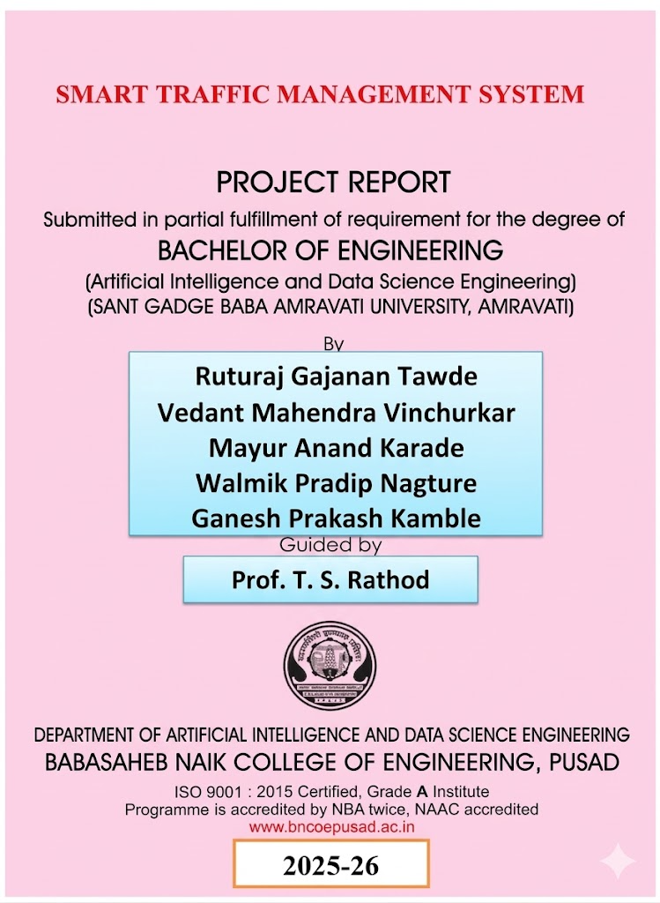




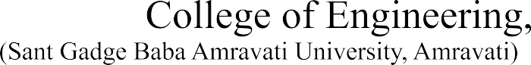



SMART TRAFFIC MANAGEMENT SYSTEM


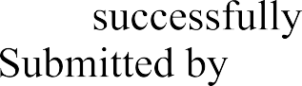

Ruturaj Gajanan Tawde
Vedant Mahendra Vinchurkar
Mayur Anand Karade
Walmik Pradip Nagture
Ganesh Prakash Kamble

Prof. T. S. Rathod












Ruturaj Gajanan Tawde
Vedant Mahendra Vinchurkar
Mayur Anand Karade
Walmik Pradip Nagture
Ganesh Prakash Kamble






SMART TRAFFIC MANAGEMENT SYSTEM
On / / 2026 at B. N. College of Engg. Pusad


Guided by
Prof. T. S. Rathod
Department of
Artificial Intelligence and Data Science

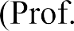
(Prof. T. S. Rathod)
Acknowledgement

We avail this opportunity to express our deep sense of gratitude and whole hearted thanks to our guide Prof. T. S. Rathod for giving his valuable guidance, inspiration and affectionate encouragement to embark this project.
We also thank our department teaching members for giving his valuable guidance and suggestion and affectionate encouragement for completion of this project.
We are also thankful to our Head of the Department, Artificial Intelligence and Data Science Engineering, Dr. A. N. Gaikwad, whose esteemed suggestions and encouragement from time to time have always been parallel stimuli for us to travel eventually towards completion of this project.
We are also thankful to our Honorable Principal Dr. Avinash Wankhade who inspired us a lot to achieve the highest goal.
Last but not least we would like to thank our teachers, parents, supporting technical staff and our friends who helped us directly or indirectly in our endeavor and infused their help for completion of this project.

Ruturaj Gajanan Tawde

Vedant Mahendra Vinchurkar Mayur Anand Karade

Walmik Pradip Nagture Ganesh Prakash Kamble

Final Year
(Artificial Intelligence & Data Science)

Table of Contents

List of Screenshots 01
List of Figures 02
Abstract………………………………………………………..…………………...03
Chapter 1 INTRODUCTION………………………………………………….04
  - Need of Smart Traffic Management 05
  - Literature Survey 06
Chapter 2 PROPOSED SYSTEM ANALYSIS AND DESIGN 08
  - Problem Statement 08
  - Features of Proposed System 08
  - Scope of the Project 10
  - Methodology 11
  - Objectives 12
Chapter 3 SPECIFICATIONS 14
  - Requirements Specification 14
    - Functional Requirements 14
    - Non-Functional Requirements 14
    - Performance Requirements ……………………………….15
  - Software and Hardware Requirements 15
    - Software Requirements 15
    - Hardware Requirements 16
  - Functional Requirements 16
  - Non-Functional Requirements 18
Chapter 4 SYSTEM ARCHITECTURE 20
  - Proposed System Architecture 20
  - Modules in the System 22
    - Frontend Component 23
    - Backend Component 24
    - Traffic Management API 25
    - Emergency Vehicle API 26
    - WebSocket Communication…………….………………....26
  - Data Flow Diagram (DFD) 26
4.3.1 DFD – Vehicle Detection Flow 28
4.3.2 DFD – Signal Timing Flow 30
4.3.3 DFD – Emergency Vehicle Flow 32
4.4 UML Diagrams 34
4.4.1 Activity Diagram – Traffic Signal Operation 34
4.4.2 Activity Diagram – Emergency Vehicle Mode 36
4.4.3 Activity Diagram – Real-Time Dashboard Updates 38
4.4.4 Class Diagram – System Modules 40
Chapter 5 IMPLEMENTATION 42
5.1 System Modules Implementation .................................................42
5.1.1 Vehicle Detection Module………. ......................................42
5.1.2 Traffic Density Calculation Module.....................................42
5.1.3 Traffic Signal Control Module ............................................42
5.1.4 Emergency Vehicle Detection Module ……………………43
5.1.5 Frontend Dashboard Module ..............................................43
5.1.6 backend Module ..................................................................43
5.2 Important Code Snippets ..............................................................44
5.3 Result of Project ...........................................................................46
5.3.1 Home Page…………….………………………..................47
5.3.2 Vehicle Detection…….........................................................48
5.3.3 Traffic Signal Timing….………………………..................49
5.3.4 Dashboard Visualization ......................................................50
5.3.5 Active Lane in dashboard………………………………….50
Chapter 6 CONCLUSION AND FUTURE SCOPE 51
  - Conclusion 51
  - Future Scope 51
  - Challenges & Solutions 52
  - Final Thoughts 51
REFERENCES 53

List of Screenshots
Screenshot 5.1 Home Page 50
Screenshot 5.2 Vehicle Detection 51
Screenshot 5.3 Traffic Signal Timing 52
Screenshot 5.4 Vehicle and green time Dashboard 53
Screenshot 5.5 Active Lane in Dashboard 54

List of Figures
Fig. 4.1 System Architecture Diagram 22
Fig. 4.2 Frontend Component Workflow 25
Fig. 4.3 Backend Component Workflow 26
Fig. 4.4 Vehicle Detection Flow 31
Fig. 4.5 Signal Timing Flow 33
Fig. 4.6 Activity Diagram- Emergency Vehicle Flow 35
Fig. 4.7 Activity Diagram – Traffic Signal Operation 37
Fig. 4.8 Activity Diagram – Emergency Vehicle Mode 39
Fig. 4.9 Real-Time Dashboard Updates 41

ABSTRACT
Traffic congestion has become one of the major challenges in modern urban areas due to the rapid increase in the number of vehicles. Traditional traffic signal systems operate on fixed time intervals without considering the actual traffic density on roads. This leads to inefficient traffic flow, increased waiting time, fuel wastage, and environmental pollution. Therefore, there is a strong need for an intelligent and automated traffic management system that can dynamically control traffic signals based on real-time traffic conditions.
The Smart Traffic Management System is designed to improve the efficiency of road traffic control using advanced technologies such as Artificial Intelligence, Computer Vision, and Machine Learning. The system uses YOLOv8 (You Only Look Once version 8) for real-time vehicle detection and classification from live video streams captured through traffic cameras. The detected vehicles are counted using OpenCV, and traffic density is calculated for each road lane. Based on the traffic density, the system dynamically adjusts the traffic signal timing to reduce congestion and waiting time.
The system also includes an Emergency Vehicle Detection Module, which identifies emergency vehicles such as ambulances and gives them immediate green signals to ensure faster movement through intersections. This feature plays a crucial role in saving lives by reducing emergency response time. The backend of the system is developed using FastAPI, which manages vehicle data processing and communication between different modules. WebSockets are used to enable real-time communication between the backend and frontend systems. The frontend dashboard is developed using React and Tailwind CSS, providing a user-friendly interface to monitor live traffic conditions, signal timing, and system performance.
The proposed Smart Traffic Management System improves traffic flow efficiency, reduces traffic congestion, minimizes waiting time at signals, and enhances road safety.

Chapter 1

INTRODUCTION
The rapid growth of urbanization and the continuous increase in the number of vehicles have significantly increased the complexity of traffic management in modern cities. Traffic congestion has become one of the most serious challenges faced by urban transportation systems. Traditional traffic signal systems are widely used at road intersections, but these systems generally operate using fixed-time intervals without considering real-time traffic density. As a result, vehicles often experience unnecessary waiting times, leading to increased fuel consumption, environmental pollution, and reduced road efficiency.
Traditional traffic management approaches mainly rely on manually configured signal timings and static scheduling methods. Although these systems are simple to implement, they fail to adapt to changing traffic conditions. In particular, during peak hours, traffic density varies significantly across different roads, but fixed-time signal systems allocate equal time to all directions regardless of the actual vehicle load. This results in longer queues on busy roads and inefficient use of available road infrastructure.
Recent advances in Artificial Intelligence, Computer Vision, and Deep Learning technologies have enabled the development of intelligent systems capable of analyzing visual data and making real-time decisions. Modern object detection models such as YOLOv8 allow accurate identification and classification of vehicles from live video streams captured by surveillance cameras. These technologies make it possible to monitor traffic conditions automatically, measure vehicle density, and dynamically adjust traffic signal timings based on real-time data.
This project, Smart Traffic Management System, presents an intelligent traffic control platform designed to simulate real-time traffic monitoring and adaptive signal management. The system uses camera-based input to detect vehicles and calculate
Traffic density using YOLOv8 and OpenCV technologies. The backend system is developed using FastAPI, which processes traffic data and controls signal timing operations. WebSockets are used to enable real-time communication between system components, while a user-friendly dashboard developed using React and Tailwind CSS provides visualization of live traffic status and signal operations.
The proposed system also includes an Emergency Vehicle Priority Module, which detects emergency vehicles such as ambulances and provides immediate green signals to ensure faster movement through intersections. This feature plays a vital role in reducing response time during emergency situations and improving public safety. By combining intelligent vehicle detection, adaptive signal control, and real-time monitoring, the Smart Traffic Management System provides an efficient and scalable solution for modern traffic challenges and supports the development of smart city infrastructure.

Need of Smart Traffic Management
With the rapid growth of urban populations and the increasing number of vehicles on city roads, traditional traffic management systems are no longer sufficient to handle the challenges of modern transportation. Fixed-time traffic signal systems do not take into account the varying traffic density at different times of the day, which often leads to traffic congestion, longer travel times, and inefficient use of road infrastructure. There is a clear need for a system that can intelligently adapt to real-time traffic conditions to improve traffic flow and reduce delays.
The primary need for a Smart Traffic Management System arises from the necessity to manage traffic more efficiently and to optimize the allocation of green signal durations according to the actual number of vehicles on each lane. By using modern technologies such as YOLOv8, OpenCV, FastAPI, and WebSockets, traffic monitoring can be automated, reducing the dependency on human supervision and minimizing errors caused by manual traffic control methods.
Another important need is emergency vehicle prioritization. In many urban areas, ambulances, fire trucks, and police vehicles often face delays due to traffic congestion. A smart system capable of detecting these vehicles in real-time and granting them immediate green signals can significantly reduce response times during emergencies, saving lives and enhancing public safety.
Furthermore, the need for real-time data visualization is essential for city authorities to monitor traffic patterns, evaluate congestion trends, and make data-driven decisions for traffic planning and road infrastructure improvements. Integration with a web-based dashboard allows authorities and traffic management teams to have complete control and insight over traffic conditions, enabling proactive measures rather than reactive solutions..

Literature Survey

With the rapid increase in urban traffic and the growing number of vehicles, traditional traffic signal systems are no longer sufficient. Fixed-time traffic signals fail to respond to dynamic road conditions, leading to congestion, increased waiting times, fuel wastage, and environmental pollution. Many cities struggle with inefficient traffic management not because of lack of infrastructure, but due to the inability of traditional systems to adapt to real-time conditions.
There is a strong need for an intelligent, real-time traffic management system that can monitor vehicle density, dynamically adjust signal timings, prioritize emergency vehicles, and provide actionable insights through dashboards.
The major needs addressed by the Smart Traffic Management System are:
1.Real-time vehicle detection and counting using computer vision (YOLOv8 + OpenCV).
2.Dynamic signal timing adjustment based on traffic density per lane.
3.Emergency vehicle prioritization, giving immediate green signals to ambulances, fire trucks, and police vehicles.
4.Web-based dashboard for live monitoring and visualization of traffic flow.
5.Data-driven decision-making for city traffic authorities.
Some reasons for adopting an AI-based smart traffic system include:
- Adaptive traffic control: Signal timings change automatically according to vehicle density on each road.
- Emergency response efficiency: Emergency vehicles get priority, reducing critical delays.
- Scalability: Multiple intersections can be managed simultaneously without
- Consistency in traffic monitoring: Automated vehicle detection ensures accurate.
Hence, the Smart Traffic Management System fulfills the growing demand for an intelligent, scalable, and adaptive traffic control solution that improves road efficiency, reduces congestion, and enhances safety in modern urban areas

Chapter 2

PROPOSED SYSTEM ANALYSIS AND DESIGN

Problem Statement
Urban traffic congestion has become a critical issue in modern cities due to the rapid increase in population and vehicle ownership. Traditional traffic management systems rely on fixed-time traffic signals that do not consider real-time traffic conditions. These systems often fail to optimize traffic flow, resulting in long waiting times, traffic jams, fuel wastage, and environmental pollution. Additionally, emergency vehicles such as ambulances, fire trucks, and police vehicles are frequently delayed due to rigid traffic signals, potentially putting lives at risk.
The problem is further compounded by limited monitoring capabilities in conventional systems, which rely on human supervision or static scheduling. Road authorities cannot make data-driven decisions without accurate real-time traffic data. This leads to inefficient traffic control and poor commuter experience.
Hence, there is a need for a Smart Traffic Management System that:
- Detects and counts vehicles in real time.
- Calculates traffic density dynamically.
- Adjusts traffic signal timings based on traffic conditions.
- Prioritizes emergency vehicles automatically.
- Provides a web-based dashboard for live traffic monitoring.
- Generates actionable insights for city traffic authorities.
The goal of the proposed system is to reduce traffic congestion, minimize waiting time at intersections, improve road safety, and provide an intelligent, scalable solution for modern urban traffic challenges.

Features of Proposed System
The Smart Traffic Management System is designed to address the limitations of conventional traffic control methods. The key features of the proposed system are as follows:

- Real-Time Vehicle Detection:
The system uses YOLOv8, a state-of-the-art object detection model, to detect vehicles in live traffic video streams captured from cameras installed at intersections.
- Vehicle Counting and Traffic Density Calculation:
Each detected vehicle is counted using OpenCV, and the traffic density for each lane is calculated. This information forms the basis for dynamic signal control.
- Dynamic Traffic Signal Control
Based on the calculated traffic density, the system automatically adjusts the traffic signal timings for each lane, ensuring smoother traffic flow and reducing waiting time at intersections.
- Emergency Vehicle Priority Mode:
Emergency vehicles such as ambulances, fire trucks, and police vehicles are automatically detected, and the system prioritizes their movement by providing immediate green signals, minimizing delays during critical situations.
- Web-Based Dashboard:
The frontend dashboard, developed using React and Tailwind CSS, allows real-time monitoring of traffic conditions, vehicle counts, signal timings, and emergency vehicle alerts.
- Real-Time Communication:
The system uses FastAPI for backend processing and WebSockets for real-time data transmission, ensuring that the dashboard updates instantly with live traffic information.
- Data Logging and Performance Analysis:
All traffic data, including vehicle counts and signal timings, is logged to allow city authorities to analyze traffic patterns, identify congestion points, and plan infrastructure improvements.
- Scalability:
The system is designed to manage multiple intersections simultaneously, making it suitable for deployment in large urban areas.
- Cost-Effective Implementation:
The system uses existing traffic cameras and minimal additional hardware,
reducing implementation costs while improving traffic efficiency.

Scope of the Project
The Smart Traffic Management System has been developed to address the growing challenges of urban traffic congestion and inefficient traffic control. The scope of the project defines the boundaries and applicability of the system. The key aspects of the project scope are as follows:
- Urban Traffic Monitoring:
The system is suitable for monitoring traffic at city intersections and high-density urban areas where vehicle congestion is a recurring problem.
- Dynamic Signal Management:
It is capable of dynamically adjusting traffic signal timings based on real-time vehicle density, ensuring optimized traffic flow for different lanes.
- Emergency Vehicle Prioritization:
The system can detect and prioritize emergency vehicles, providing immediate green signals to reduce response time during emergencies.
- Real-Time Data Visualization:
City authorities and traffic operators can monitor live traffic conditions through a web-based dashboard, enabling faster decision-making.
- Scalability Across Multiple Intersections:
The system can be scaled to manage multiple junctions simultaneously, making it suitable for larger city networks.
- Integration with Existing Infrastructure:
The system is designed to work with existing traffic cameras and minimal additional hardware, making deployment cost-effective.
- Data Logging and Analysis:
Traffic data is stored for performance analysis, congestion pattern detection, and infrastructure planning, supporting long-term traffic management strategies.
- Enhancement for Smart Cities:
The system provides a foundation for future integration with IoT devices, cloud-based traffic control, and predictive analytics in smart city initiatives.

Methodology
The methodology for developing the Smart Traffic Management System is based on a structured, systematic approach that integrates computer vision, artificial intelligence, and web technologies. The following steps outline the methodology used to design, implement, and deploy the system:
- Data Collection:
Video data of traffic from city intersections is collected using existing CCTV cameras. The dataset includes various types of vehicles such as cars, buses, trucks, and two-wheelers, as well as emergency vehicles like ambulances
- Vehicle Detection Using YOLOv8:
YOLOv8, a state-of-the-art object detection model, is trained and fine-tuned to detect vehicles in each video frame. The model is optimized for accuracy and speed to ensure real-time performance.
- Frame Processing with OpenCV:
The traffic video is divided into frames using OpenCV. Each frame is pre-processed (resized, filtered, and normalized) to improve detection accuracy.
- Vehicle Counting and Traffic Density Calculation:
Detected vehicles are counted per lane in each frame. Traffic density is calculated using the vehicle count to determine the load on each lane.
- Dynamic Signal Timing Algorithm:
Signal timing is dynamically calculated based on the density of vehicles. Lanes with higher vehicle density are allocated longer green signals, while less congested lanes receive shorter durations.
- Emergency Vehicle Detection and Prioritization:
The system identifies emergency vehicles in real-time.Upon detection, green signals are immediately granted to the corresponding lane to allow uninterrupted movement.
- Backend Implementation using FastAPI:
The backend handles all data processing, vehicle count calculations, and signal control.FastAPI endpoints provide APIs for the frontend dashboard and real-time updates.

- Real-Time Communication via WebSockets:
WebSockets enable live communication between the backend and the frontend dashboard.
- Frontend Dashboard Development:
A web-based dashboard is developed using React and Tailwind CSS.
The dashboard displays vehicle counts, signal timings, traffic density maps, and emergency alerts in a user-friendly interface.
- System Testing and Evaluation:
The system is tested under different traffic scenarios to evaluate accuracy, response time, and reliability. Metrics such as vehicle detection accuracy, traffic flow efficiency, and emergency response time are recorded.

Objectives
The primary objective of the Smart Traffic Management System is to improve urban traffic flow, reduce congestion, and enhance road safety by using intelligent technologies. The specific objectives of the project are as follows:
- Real-Time Vehicle Detection:
To accurately detect and classify different types of vehicles such as cars, buses, trucks, and motorcycles in real-time using YOLOv8 and OpenCV.
- Dynamic Traffic Signal Control:
To implement adaptive signal timing that automatically adjusts green signal duration based on traffic density in each lane.
- Emergency Vehicle Prioritization:
To detect emergency vehicles such as ambulances and fire trucks and provide immediate green signals to minimize response time.
- Real-Time Traffic Monitoring Dashboard:
To develop a user-friendly dashboard using React and Tailwind CSS that
displays live traffic information, vehicle counts, and signal status.
- Backend Data Processing:
To implement a robust backend using FastAPI that handles vehicle detection data, signal timing calculations, and real-time communication via WebSockets.
- Traffic Data Logging and Analysis:
To store traffic data for performance evaluation, congestion pattern analysis, and planning of future traffic infrastructure.
- Scalable System Architecture:
To design the system so that it can be scaled to manage multiple intersections simultaneously, making it suitable for large urban areas.
- Reduction of Waiting Time and Congestion:
To optimize traffic flow, reduce idle time at intersections, and decrease overall travel time for commuters.
- Cost-Effective Implementation:
To utilize existing traffic camera infrastructure, minimizing additional hardware costs while improving efficiency.
- Foundation for Smart City Integration:
To create a system that can be further integrated with IoT devices, cloud computing, and predictive analytics for future smart city traffic solutions.

Chapter 3

SPECIFICATIONS

Requirements Specification
The Smart Traffic Management System is designed with specific software and hardware requirements to ensure efficient operation and real-time performance. The requirements are divided into functional, non-functional, performance, software, and hardware specifications.
3.1.1 Functional Requirements
Functional requirements define the specific behavior of the system and the tasks it must perform:
  - Detect vehicles in real-time using video streams from traffic cameras.
  - Classify vehicles into types: car, bus, truck, motorcycle, and emergency vehicles.
  - Count the number of vehicles in each lane.
  - Calculate traffic density and determine optimal signal timings.
  - Dynamically control traffic lights based on traffic conditions.
  - Detect emergency vehicles and give immediate green signals.
  - Display live traffic data, vehicle counts, and signal status on a web-based dashboard.
  - Enable real-time updates between backend and frontend using WebSockets.
  - Log traffic data for future analysis and reporting.
3.1.2 Non-Functional Requirements
Non-functional requirements define system attributes such as performance, usability, and reliability:
- Performance: System must process video frames in real-time with minimal delay.
- Scalability: System should handle multiple intersections simultaneously.
- Reliability: System must provide consistent detection accuracy and stable operation.
- Usability: The dashboard should be user-friendly and easily understandable by traffic operators.
- Maintainability: The system should allow easy updates and modifications to models, algorithms, and dashboards.
3.1.3 Performance Requirements
- Minimum vehicle detection accuracy: 95%.
- Frame processing rate: ≥ 20 frames per second.
- Dashboard update interval: ≤ 1 Minimum second for real-time display.
- Emergency vehicle detection response time: ≤ 2 seconds.

Software and Hardware Requirements

Software Requirements
The following software components are required for the Smart Traffic Management System:
  - Operating System: Windows 10 / Ubuntu 20.04 or higher
  - Programming Languages: Python 3.9+ (for backend and computer vision) JavaScript (React) for frontend development
  - Frameworks and Libraries:
- YOLOv8 – for real-time vehicle detection
- OpenCV – for video frame processing and image analysis
- FastAPI – for backend API development
- WebSockets – for real-time communication
- React – for frontend dashboard interface
- Tailwind CSS – for styling the dashboard
- NumPy / Pandas / Matplotlib – for data handling and visualization
4.Database: SQLite / MySQL (for storing vehicle counts and traffic logs)
5.Web Browser: Google Chrome / Mozilla Firefox (latest versions) for dashboard display.
6.Development Tools:
1.VS Code / PyCharm for coding and debugging
2.Git / GitHub for version control
3.2.2 Hardware Requirements
The following hardware specifications are recommended for efficient system operation:
1.Processor: Intel i5 / i7 8th generation or higher, or equivalent AMD CPU
2.RAM: Minimum 8 GB, Recommended 16 GB
3.Graphics Processing Unit (GPU): NVIDIA GPU with CUDA support (for real- time YOLOv8 processing) Minimum 4 GB VRAM
4.Storage: Minimum 500 GB HDD / SSD for video storage and system data
5.Camera / Video Input: High-resolution CCTV or IP cameras capable of 720p / 1080p video
6.Network Connectivity: Stable Internet connection for real-time dashboard updates and WebSocket communication
7.Display: Monitor for visualizing the dashboard and system outputs

3.3 Functional Requirements
The functional requirements of the Smart Traffic Management System define the core capabilities and operations that the system must perform to achieve its objectives. These requirements ensure that the system can effectively manage urban traffic in real-time while maintaining accuracy and reliability.
1. Real-Time Vehicle Detection:
The system must detect all types of vehicles in live video streams captured from traffic cameras. Vehicle types include cars, buses, trucks, motorcycles, and emergency vehicles.
2. Vehicle Counting Per Lane:
Each detected vehicle must be counted accurately per lane to determine the traffic density for that lane. The count should be updated continuously in real-time.
3. Traffic Density Calculation:
Using the vehicle count data, the system calculates traffic density for each lane and identifies congested lanes.
4. Dynamic Traffic Signal Control:
Traffic signals must adjust dynamically according to the calculated density. Lanes with higher traffic density receive longer green signals, while less crowded lanes receive shorter green time.
5. Emergency Vehicle Prioritization:
The system should detect emergency vehicles such as ambulances and fire trucks. Upon detection, the system must immediately assign green signals to the lane containing the emergency vehicle.
6. Real-Time Dashboard Display:
The system must provide a web-based dashboard that displays live vehicle counts, signal timings, traffic density visualization, and emergency alerts.
7. Backend Data Processing and API Integration:
The backend must process all traffic data, handle calculations, and provide APIs for the dashboard to fetch real-time information.
8. Data Logging and Reporting:
All traffic data, including vehicle counts, signal timings, and emergency vehicle detection, should be logged for performance evaluation and reporting purposes.
9. Scalable Multi-Intersection Management:
The system should support management of multiple intersections simultaneously, ensuring consistent performance across a city-wide network.
10. System Alerts and Notifications:
The system should provide automated alerts in case of emergency vehicle detection, system errorsr abnormal traffic conditions.

3.4 Non-Functional Requirements
Non-functional requirements describe the system attributes, quality standards, and performance criteria that ensure the Smart Traffic Management System operates efficiently, reliably, and securely. These requirements are essential to maintain overall system usability and robustness.
1. Performance Requirements
1.Real-Time Processing: The system must process live video streams and update traffic data with minimal delay.
2.Frame Rate: Video frames should be processed at a minimum of 20–25 frames per second to maintain real-time accuracy.
3.Signal Adjustment Latency: Dynamic traffic signal timings must be recalculated and applied within 2–3 seconds of detecting traffic density changes.
4.Emergency Vehicle Response: Emergency vehicle detection and green signal activation should occur within 2 seconds.
2. Reliability and Availability
1.System Uptime: The system should be operational 24/7 with minimal downtime.
2..Error Handling: The system must detect and handle errors gracefully without affecting traffic flow.
3.Fault Tolerance: If one intersection module fails, other intersections must continue to operate normally.
3. Usability
- Dashboard Interface: The web dashboard must be intuitive, user-friendly, and accessible to traffic operators without specialized training.
- Visual Feedback: Vehicle counts, signal status, and emergency alerts should be clearly visible.
- Accessibility: The dashboard should be compatible with standard web browsers (Chrome, Firefox).
4. Scalability
- Multi-Intersection Support: The system must scale to manage multiple intersections simultaneously.
- Data Handling: Should handle large volumes of video and traffic data efficiently without performance degradation
5. Maintainability
- Modular Design: Each system module (vehicle detection, signal control, dashboard) should be independent to allow easy updates.
- Software Updates: The system should allow seamless software and model updates without full downtime.
- Code Documentation: All code should be well-documented for future developers.
6. Security
- Data Security: All traffic and system data must be securely stored and transmitted.
- Access Control: Only authorized users should be able to access the dashboard and modify system settings.
- API Security: Backend APIs must be protected against unauthorized access and data breaches.
.

Chapter 4

SYSTEM ARCHITECTURE

4.1 Proposed System Architecture
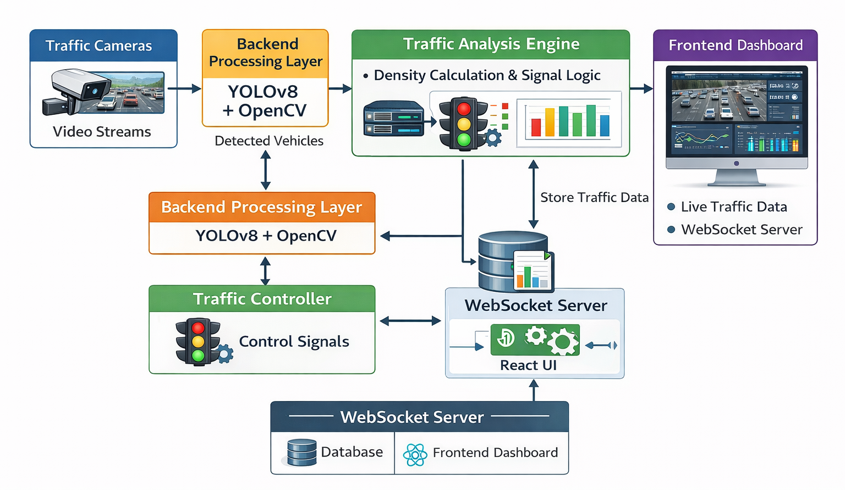
Fig. 4.1 : System Architecture
The Smart Traffic Management System is designed as a modular and scalable architecture that integrates real-time vehicle detection, dynamic signal control, emergency vehicle prioritization, and a web-based dashboard for monitoring. The architecture is divided into three main layers: Data Acquisition Layer, Processing Layer, and Presentation Layer.
1. Data Acquisition Layer
- Traffic Cameras: CCTV or IP cameras capture live video streams from intersections.
- Video Input: High-resolution videos (720p / 1080p) are fed into the system for processing.
- Emergency Vehicle Detection: Special camera algorithms identify emergency vehicles based on pre-trained models.

2. Processing Layer
- Vehicle Detection Module: Uses YOLOv8 for real-time object detection to identify and classify vehicles.
- Vehicle Counting & Traffic Density: OpenCV processes the detected vehicles to calculate the density for each lane.
- Dynamic Signal Control Module: Calculates optimal green signal durations based on real-time traffic density.
- Emergency Vehicle Priority Module: Detects emergency vehicles and overrides normal signal timings to provide immediate green signals.
- Backend Server (FastAPI): Manages all processing, calculations, API endpoints, and real-time communication with the frontend via WebSockets.
3. Presentation Layer
- Dashboard Interface (React + Tailwind CSS): Displays live traffic conditions, vehicle counts, signal timings, and emergency alerts.
- Data Visualization: Real-time charts, lane-wise traffic density, and signal status are visualized for easy understanding.
- Real-Time Updates: The dashboard automatically refreshes with updates from the backend server.
Workflow Description
- Traffic cameras capture video streams.
- Video frames are processed for vehicle detection using YOLOv8.
- Vehicles are counted per lane, and traffic density is calculated.
- Signal timing is dynamically adjusted based on density.
- Emergency vehicles are detected, and green signals are prioritized.
- Processed data is sent to the dashboard via WebSockets for real-time monitoring.
- Traffic data is logged for analysis and reporting.
This architecture ensures that the system is real-time, scalable, modular, and responsive, providing an intelligent solution for urban traffic management.

4.2 Modules in the System

The Smart Traffic Management System is divided into multiple functional modules to ensure modularity, scalability, and ease of maintenance. Each module is responsible for a specific functionality of the system:

Vehicle Detection Module: Detects vehicles in real-time using YOLOv8.

Vehicle Counting & Traffic Density Module: Counts vehicles per lane and calculates traffic density using OpenCV.

Traffic Signal Control Module: Dynamically adjusts signal timings based on traffic density.

Emergency Vehicle Detection Module: Detects ambulances, fire trucks, and other emergency vehicles to give immediate green signals.

Backend Module (FastAPI): Handles all processing, calculation, API endpoints, and communication with the frontend.

Frontend Dashboard Module (React + Tailwind CSS): Displays real-time traffic information, vehicle counts, signal timings, and alerts.

Real-Time Communication Module (WebSockets): Ensures live updates between backend and frontend.

Data Logging & Reporting Module: Stores traffic data for analysis and future planning.

4.2.1 Frontend Component
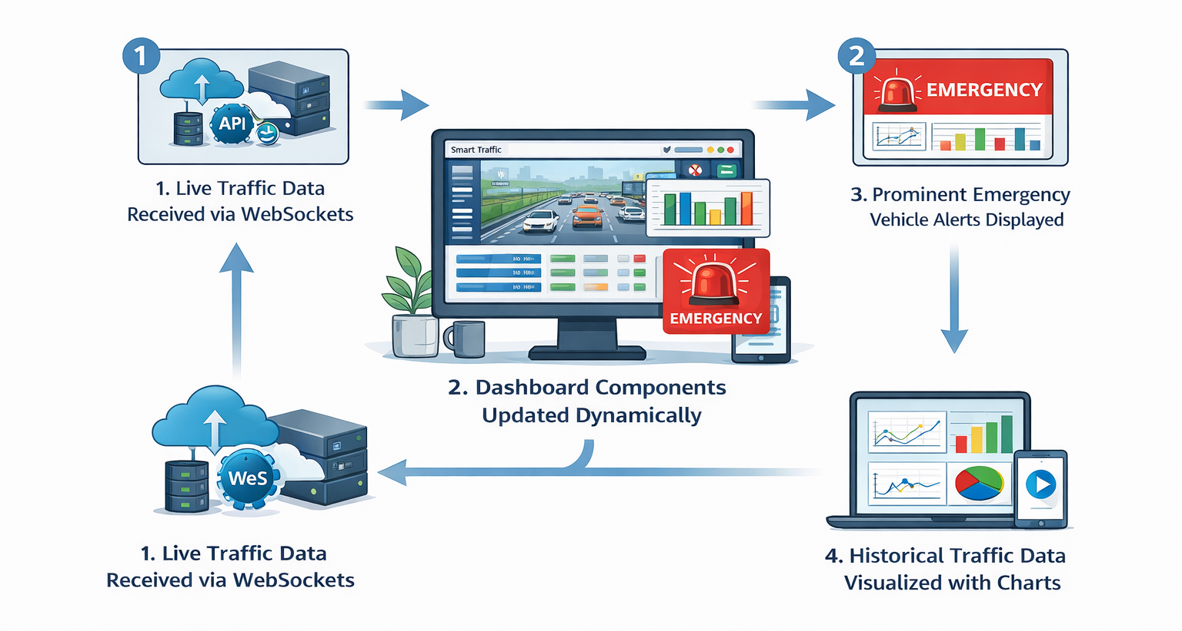
Fig. 4.2 : Frontend Component Workflow

The Frontend Component Architecture is responsible for visualizing traffic data and interacting with the user. Key components include:
- Dashboard Display: Shows live vehicle counts, signal status, and lane-wise traffic density.
- Signal Timing Panel: Displays current green, yellow, and red signal durations for each lane.
- Emergency Vehicle Alert Panel: Highlights emergency vehicles and lane priority status.
- Traffic Flow Charts: Graphical representation of traffic density trends and performance metrics.
- Real-Time Update Handler: Subscribes to WebSocket data from the backend to refresh dashboard content automatically.
- User Controls: Allows authorized personnel to view system status, reset modules, or adjust configurations as required.
Workflow:
- Frontend receives live traffic data via WebSockets.
- Dashboard components update the visual elements dynamically.
- Alerts for emergency vehicles are displayed prominently.
- Historical traffic data is visualized using charts for performance analysis.
This architecture ensures a user-friendly, real-time, and interactive interface for monitoring and managing traffic at multiple intersections.

4.2.2 Backend Component

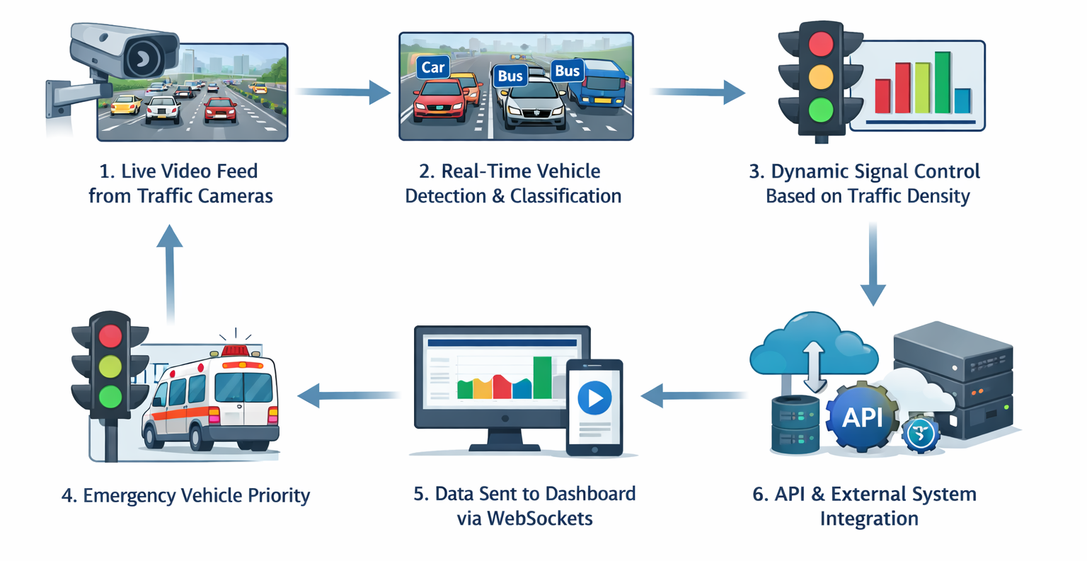
Fig. 4.3 : Backend Component Workflow

The Backend Component Architecture is the core of the Smart Traffic Management System, responsible for processing all traffic data, controlling signal timings, and communicating with the frontend in real-time. The backend is designed for scalability, reliability, and real-time performance.
Key Components of the Backend
- API Layer (FastAPI):
  - Provides RESTful endpoints for frontend data access.
  - Handles requests for vehicle counts, signal statuses, traffic density, and emergency alerts.
- Vehicle Detection Processor:
  - Receives video frames from traffic cameras.
  - Uses YOLOv8 for detecting vehicles in each frame.
  - Classifies vehicles into types: cars, buses, trucks, motorcycles, and emergency vehicles.
- Traffic Density & Signal Control Engine:
  - Calculates lane-wise traffic density using vehicle counts.
  - Determines optimal signal timing based on traffic load per lane.
  - Updates signal status dynamically and triggers timing changes.
- Emergency Vehicle Priority Module:
  - Continuously monitors for emergency vehicles.
  - Overrides normal signal control to provide immediate green signals for emergency lanes.
- Real-Time Communication Module (WebSockets):
  - Pushes updates to the frontend dashboard in real-time.
  - Ensures that dashboard components display live vehicle counts, signal changes, and alerts instantly.
- Database & Logging:
  - Stores vehicle counts, signal timings, emergency events, and historical traffic data.
  - Supports analysis and performance evaluation for city traffic management.

Backend Workflow
- Traffic cameras send live video to the backend processor.
- Vehicle detection and classification are performed in real-time.

- Traffic density is computed and signal timings are adjusted dynamically.
- Emergency vehicles are identified and green signals are applied to their lanes.
- Processed data is logged and sent via WebSockets to the frontend dashboard.
- The API layer handles dashboard requests and external system integration.
The backend is designed to be robust, modular, and scalable, capable of handling multiple intersections simultaneously and processing high-volume video streams without performance degradation.

4.2.3 Traffic Management API
This module provides real-time traffic data to the dashboard and other integrated systems.
Endpoints:
  - GET /vehicle-count – Returns vehicle counts per lane.
  - GET /traffic-density – Provides current traffic density for each lane.
  - GET /signal-status – Returns the current traffic signal state for all intersections.
  - POST /update-signal – Allows manual override of signal timings (for emergency or testing).
Features:
  - Real-time data retrieval for dashboard visualization.
  - Supports multiple intersections simultaneously.
  - Secure access for authorized systems only.

4.2.4 Emergency Vehicle API
This module ensures the prioritization of emergency vehicles.
Endpoints:
  - GET /emergency-vehicles – Returns real-time locations of detected emergency vehicles.
  - POST /emergency-signal – Triggers green signal for the emergency vehicle lane.
Features:
  - Immediate signal adjustment for emergency vehicles.
  - Alerts dashboard operators about emergency vehicle movements.
  - Logs all emergency events for later analysis.

4.2.5 WebSocket Communication
- Real-time updates are pushed to the frontend via WebSockets.
- Updates include vehicle counts, signal changes, traffic density, and emergency alerts.
- Ensures the dashboard reflects live conditions without polling APIs continuously.

4.3 Data Flow Diagram (DFD)

The Data Flow Diagram (DFD) represents how data moves through the Smart Traffic Management System. It illustrates the interactions between different modules, how input is processed, and how output is delivered to the dashboard and other stakeholders.

The DFD is divided into three levels:

1.Level 0 – Context Diagram:
Shows the system as a single process interacting with external entities such as traffic cameras, city authorities, and emergency vehicles.

2.Level 1 – Main Processes:
Illustrates major modules including Vehicle Detection, Traffic Density Calculation, Signal Control, Emergency Vehicle Prioritization, and Dashboard Visualization.

3.Level 2 – Detailed Sub-Processes:
Breaks down each main process into detailed tasks, such as frame extraction, vehicle counting, signal timing calculation, API communication, and real-time updates.

4.3.1 DFD – Vehicle Detection Flow

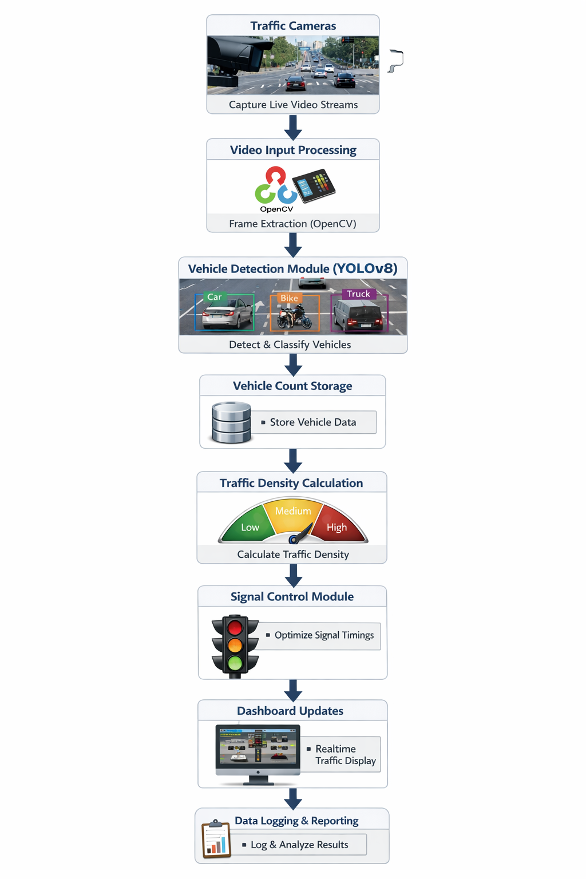
Fig. 4.4 : Vehicle Detection Flow

This DFD describes the flow of data from the traffic cameras to the vehicle detection module and finally to the signal control and dashboard:
- Traffic Cameras: Capture live video streams from intersections.
- Video Input Processing: Frames are extracted from video using OpenCV.
- Vehicle Detection Module (YOLOv8): Detects and classifies each vehicle in the frame.

- Vehicle Count Storage: Detected vehicles are counted and stored in the database per lane.
- Traffic Density Calculation: Uses vehicle counts to compute traffic density for each lane.
- Signal Control Module: Receives traffic density and calculates optimal green signal durations.
- Dashboard Updates: Traffic data and vehicle counts are sent via WebSockets to the dashboard in real-time.
- Data Logging: Vehicle detection results are logged for future analysis and reporting.

4.3.2 DFD – Signal Timing Flow
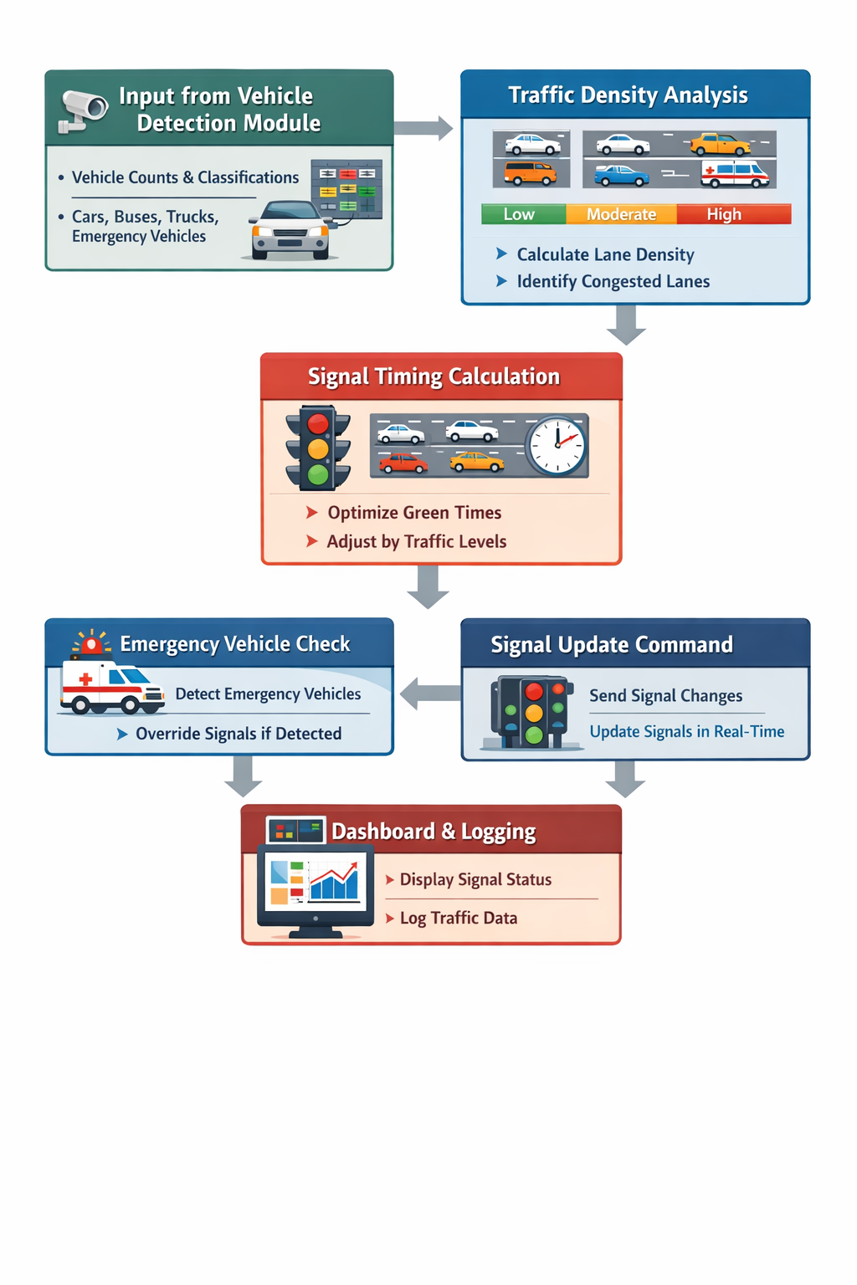
Fig. 4.5 : Signal Timing Flow

The Traffic Signal Control Flow describes how the system manages traffic signals dynamically based on real-time data from vehicle detection. It ensures efficient traffic movement and prioritization of congested lanes or emergency vehicles.
Step-by-Step Flow
- Input from Vehicle Detection Module:
Vehicle counts per lane and classifications (cars, buses, trucks, motorcycles, emergency vehicles) are sent to the signal control module.
- Traffic Density Analysis:
  - The system calculates traffic density for each lane using vehicle count data.
  - Congested lanes are identified based on pre-defined density thresholds
- Signal Timing Calculation:
  - Dynamic algorithms determine optimal green signal duration for each lane.
  - Less congested lanes receive shorter green times, while busier lanes are given longer green signals.
- Emergency Vehicle Check:
  - The module continuously checks for detected emergency vehicles.
  - If an emergency vehicle is detected, normal signal timing is overridden to provide immediate green signal for the corresponding lane.
- Signal Update Command:
  - Calculated timings are sent to the traffic signal hardware/controller.
  - Signals are updated in real-time based on lane priorities and emergency vehicle status.
- Dashboard & Logging:
  - Updated signal status is transmitted via WebSockets to the dashboard.
  - Signal timings and traffic density data are logged for historical analysis and reporting.

4.3.3 DFD – Emergency Vehicle Flow
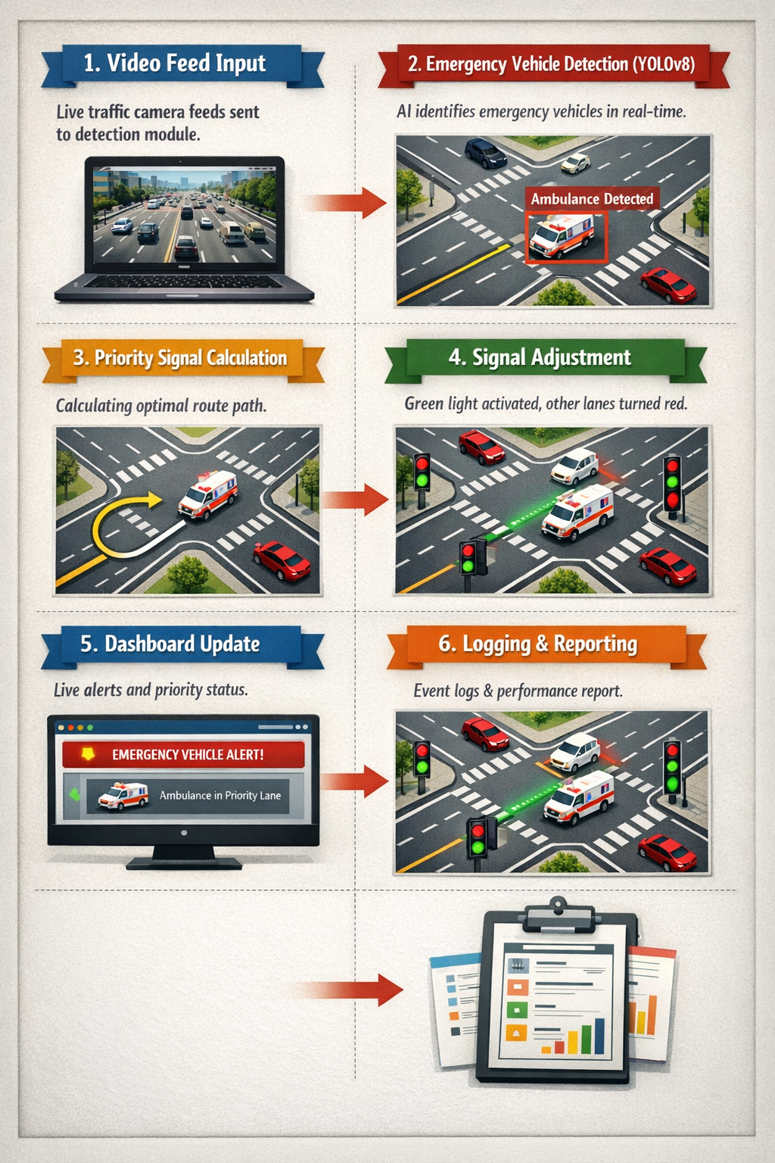
Fig. 4.6 : Emergency Vehicle Flow

The Emergency Vehicle Flow in the Smart Traffic Management System ensures that emergency vehicles such as ambulances, fire trucks, and police vehicles receive immediate priority at intersections. This module integrates with vehicle detection and traffic signal control to minimize response times.
Step-by-Step Flow
- Video Feed Input:
  - Traffic cameras capture live video of all lanes.
  - Frames are continuously sent to the vehicle detection module.
- Emergency Vehicle Detection (YOLOv8):
  - The detection module identifies emergency vehicles using pre-trained classification models.
  - Emergency vehicle presence, lane position, and direction are recorded in real-time.
- Priority Signal Calculation:
  - If an emergency vehicle is detected, the system calculates the shortest possible route through the intersection.
  - Current signal timings for the lane containing the emergency vehicle are overridden.

- Signal Adjustment:
  - Green signal is immediately activated for the emergency vehicle lane.
  - Conflicting lanes are temporarily given red signals to ensure safe passage.
- Dashboard Update:
  - The real-time dashboard highlights emergency vehicles and their lane priority.
  - Operators receive visual alerts to monitor the situation.
- Logging & Reporting:
  - All emergency events are logged with timestamps for future analysis.
  - System generates a report of emergency vehicle handling efficiency.

4.4 UML Diagrams
Unified Modeling Language (UML) diagrams are used to visually represent the structure and behavior of the Smart Traffic Management System. They help in understanding the system’s workflow, module interactions, and data processing logic.

Activity Diagram – Traffic Signal Operation

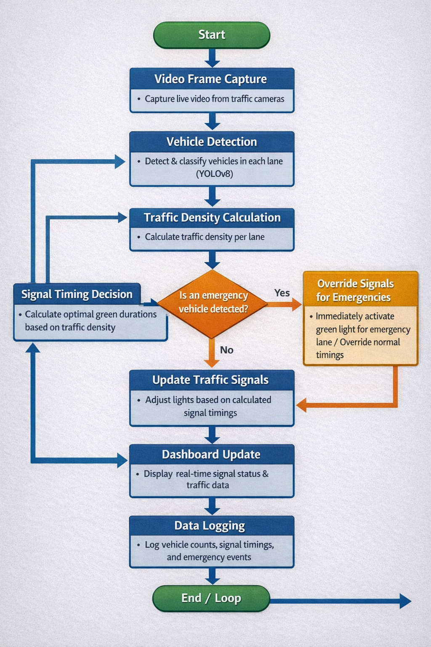

Fig. 4.7 : Activity Diagram – Traffic Signal Operation

The Activity Diagram illustrates the step-by-step process of traffic signal management in real-time:
- Start: System begins monitoring all intersections.
- Video Frame Capture: Traffic cameras capture live video frames.
- Vehicle Detection: YOLOv8 detects and classifies vehicles in each lane.
- Traffic Density Calculation: Vehicle counts are processed to determine lane-wise traffic density.

- Signal Timing Decision: Based on traffic density, optimal green light durations are calculated for each lane.
- Emergency Vehicle Check: System checks for any emergency vehicle presence.
  - If emergency vehicle detected: Override normal signal timings and provide immediate green signal.
  - Else: Continue normal dynamic signal control.
- Update Traffic Signals: Signals are updated according to calculated timings.
- Dashboard Update: Real-time signal status and traffic data are displayed on the dashboard.
- Data Logging: All vehicle counts, signal timings, and emergency events are logged.
- End / Loop: System continuously monitors intersections in a loop for real-time operation.

Activity Diagram – Emergency Vehicle Mode
The Emergency Vehicle Mode Activity Diagram describes the workflow for detecting emergency vehicles and providing immediate priority at intersections. This ensures minimal delay and safe passage for ambulances, fire trucks, and police vehicles.

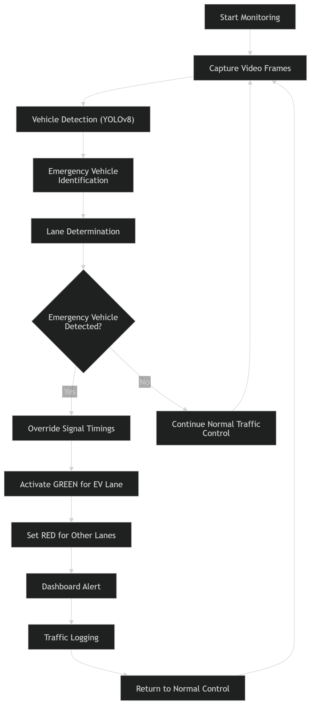
Fig. 4.8 : Activity Diagram – Emergency Vehicle Mode

Step-by-Step Workflow
- Start Monitoring: The system continuously monitors all intersections via traffic cameras.
- Capture Video Frames: Cameras provide real-time video input to the detection module.
- Vehicle Detection (YOLOv8): All vehicles in the frame are detected and classified.
- Emergency Vehicle Identification: The system identifies vehicles marked as emergency vehicles (ambulances, fire trucks, police).
- Lane Determination: The lane in which the emergency vehicle is located is determined.
- Signal Override Decision:
  - If an emergency vehicle is detected: Current signal timings for the lane are overridden.
  - Immediate green signal is activated for the lane.
  - Other lanes receive temporary red signals to ensure safety.
- Dashboard Alert:
- Visual and textual alerts for emergency vehicles are displayed on the web dashboard.
- Traffic Logging:
    - All emergency events are logged with timestamps for future performance evaluation.
- Return to Normal Control:
- Once the emergency vehicle passes, normal dynamic traffic signal control resumes.

Activity Diagram – Real-Time Dashboard Updates

The Real-Time Dashboard Activity Diagram illustrates how the Smart Traffic Management System updates live traffic data, signal statuses, and emergency alerts on the web dashboard in real time. This ensures traffic operators always have an accurate view of current conditions.

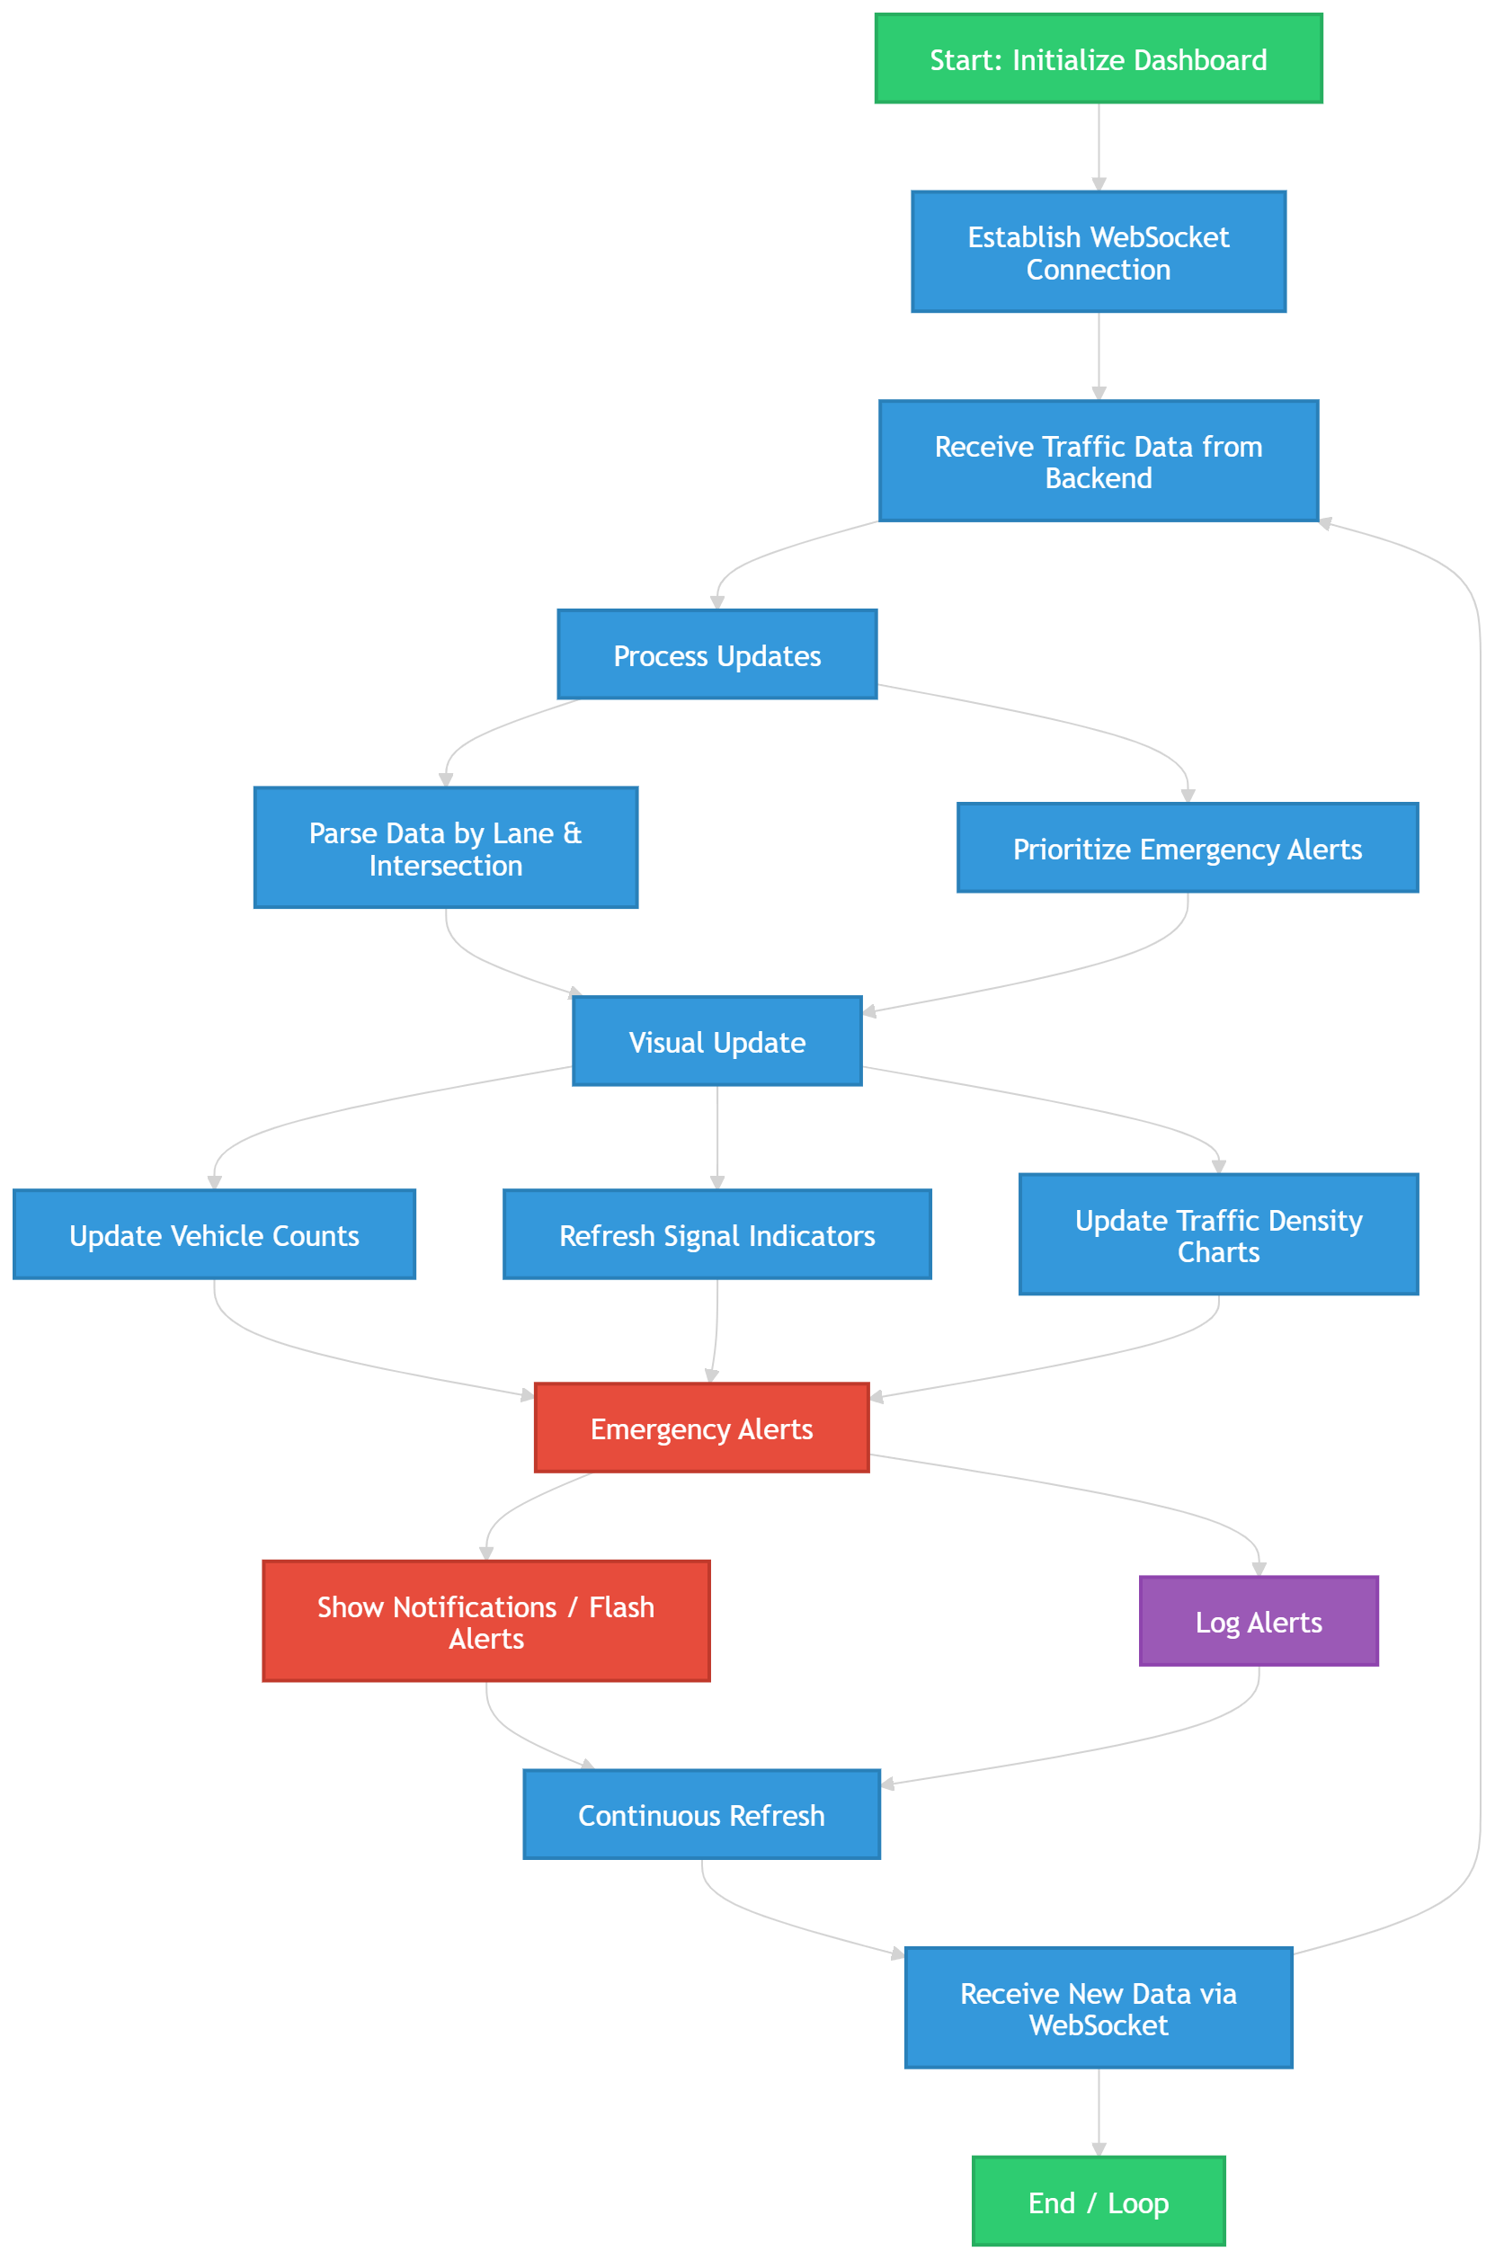
Fig. 4.9 : Activity Diagram – Real-Time Dashboard Updates
Step-by-Step Workflow
- Start: Dashboard module initializes and establishes a WebSocket connection with the backend server.
- Receive Traffic Data: Backend sends vehicle counts, traffic density, and signal timings for all intersections.
- Process Updates:
  - Data is parsed and organized by lane, intersection, and signal state.
  - Emergency vehicle alerts are prioritized for display.
- Visual Update:
  - Lane-wise vehicle counts are updated.
  - Signal timing indicators (Green, Yellow, Red) are refreshed.

  - Traffic density charts are updated to reflect current conditions.
- Emergency Alerts:
  - Flashing indicators or notifications are displayed for emergency vehicles.
  - Alerts are logged for reference and operator awareness.
- Continuous Refresh:
  - The dashboard continuously receives updates from the backend via WebSockets.
  - Data refresh occurs without manual page reload, providing a seamless real-time view.
- End / Loop: System continuously updates the dashboard for all intersections.

Class Diagram – System Modules
The Class Diagram represents the structure of the Smart Traffic Management System, showing the system’s main modules, their attributes, and relationships. This diagram provides a clear view of how different components interact to manage traffic efficiently.
Main Classes and Responsibilities
- Camera Module
  - Attributes: camera ID, location, video Stream
  - Methods: capture Frame(), send Frame(), adjust Resolution()
  - Responsible for capturing live video from traffic cameras and sending frames for processing.
- Vehicle Detection Module
  - Attributes: detected Vehicles, vehicle Type, frame Number
  - Methods: detect Vehicles(frame), classify Vehicle(vehicle)
  - Detects and classifies vehicles using YOLOv8 in real-time.
- Traffic Density Module
  - Attributes: lane Vehicle Count, lane Density, intersection ID
  - Methods: calculate Density(vehicle Counts), update Density()
  - Computes traffic density for each lane based on vehicle counts.
- Signal Control Module
  - Attributes: current Signal State, green Time, red Time, yellow Time
  - Methods: adjust Signal(density), override For Emergency()

  - Dynamically adjusts traffic signal timings and prioritizes emergency vehicles.
- Emergency Vehicle Module
  - Attributes: emergency Vehicle ID, lane, status
  - Methods: detect Emergency (frame), activate Priority Signal()
  - Identifies emergency vehicles and triggers immediate green signals.
- Dashboard Module
  - Attributes: vehicle Counts, signal Status, alerts
  - Methods: update Dashboard(), display Alerts(), refresh Charts()
  - Displays live traffic data, signal states, and emergency alerts to operators.
- Backend Server
a.Attributes: api Endpoints, web Socket Connections, database
b.Methods: process Frame(), send Updates(), log Data()
c.Handles processing, data storage, API requests, and real-time communication with the frontend.
Relationships
- Camera Module → Vehicle Detection Module: feeds video frames for detection.
- Vehicle Detection Module → Traffic Density Module: provides vehicle counts.
- Traffic Density Module → Signal Control Module: sends density data for timing calculation.
- Emergency Vehicle Module → Signal Control Module: overrides signal for emergency vehicles.
- Backend Server ↔ Dashboard Module: communicates real-time data via Web Sockets.
- All modules log events and results to the Database.

Chapter 5

IMPLEMENTATION
5.1 System Modules Implementation
The implementation of the Smart Traffic Management System is divided into multiple modules, each responsible for a specific functionality. This modular approach ensures maintainability, scalability, and efficient system performance.
5.1.1 Vehicle Detection Module
- Purpose: Detects and classifies vehicles in real-time from live video streams.
- Technology Used: YOLOv8, OpenCV, Python.
- Implementation Details:
  - Frames are captured from traffic cameras using OpenCV.
  - YOLOv8 model processes each frame to detect vehicles.
  - Vehicles are classified as cars, buses, trucks, motorcycles, or emergency vehicles.
  - Detection results are stored in the database and sent to the traffic density module.
5.1.2 Traffic Density Calculation Module
- Purpose: Calculates traffic density per lane for signal timing decisions.
- Implementation Details:
  - Counts vehicles in each lane from the detection module.
  - Calculates density using lane length and number of vehicles.
  - Outputs density data to the signal control module.
5.1.3 Traffic Signal Control Module
- Purpose: Dynamically adjusts traffic signals based on real-time density.
- Implementation Details:
  - Receives density data from the traffic density module.
  - Calculates green, yellow, and red light durations dynamically.
  - Overrides normal timings if an emergency vehicle is detected.

5.1.4 Emergency Vehicle Detection Module
- Purpose: Prioritizes emergency vehicles at intersections.
- Implementation Details:
- Uses YOLOv8 to detect ambulances and fire trucks.
- Activates green signal immediately for the emergency vehicle lane.
- Alerts the dashboard and logs events for reporting.
5.1.5 Frontend Dashboard Module
- Purpose: Provides visualization and monitoring interface.
- Technology Used: React, Tailwind CSS, WebSockets.
- Implementation Details:
  - Displays lane-wise vehicle counts, signal timings, and alerts.
  - Refreshes automatically using WebSockets for real-time updates.
  - Provides historical charts and data for analysis.
5.1.6 Backend Module
- Purpose: Handles processing, APIs, real-time communication, and data storage.
- Technology Used: Python, FastAPI, SQLite/MySQL, WebSockets.
- Implementation Details:
  - Processes video frames, vehicle detection, and density calculations.
  - Updates dashboard in real-time via WebSockets.
  - Stores all traffic data and emergency events in the database.

5.2 Important Code Snippets
The following code snippets illustrate the key implementation of the Smart Traffic Management System. These examples highlight how vehicles are detected, counted, and used for dynamic signal control.

1. Vehicle Detection Using YOLOv8
import cv2
from ultralytics import YOLO
# Load YOLOv8 model
model = YOLO('yolov8n.pt')
# Capture video from traffic camera
cap = cv2.VideoCapture('traffic_video.mp4')
while cap.isOpened():
ret, frame = cap.read()
if not ret:
break
# Detect vehicles
results = model(frame) # Draw bounding boxes on vehicles
for result in results:
for box in result.boxes:
x1, y1, x2, y2 = map(int, box.xyxy[0])
cv2.rectangle(frame, (x1, y1), (x2, y2), (0,255,0), 2)
cv2.imshow('Vehicle Detection', frame)

if cv2.waitKey(1) & 0xFF == ord('q'):
break
cap.release()
cv2.destroyAllWindows()

2. Vehicle Counting per Lane
vehicle_count = {'lane_1': 0, 'lane_2': 0, 'lane_3': 0}
for vehicle in detected_vehicles:
lane_id = determine_lane(vehicle) # Function to identify lane
vehicle_count[lane_id] += 1
3. Dynamic Signal Timing Calculation
def calculate_signal_time(vehicle_count, max_time=60):
total_vehicles = sum(vehicle_count.values())
signal_times = {}
for lane, count in vehicle_count.items():
signal_times[lane] = int((count / total_vehicles) * max_time)
return signal_times
4. Emergency Vehicle Priority
def check_emergency(detected_vehicles):
for vehicle in detected_vehicles:
if vehicle.type == 'ambulance' or vehicle.type == 'fire_truck':
return vehicle.lane
return None
emergency_lane = check_emergency(detected_vehicles)
if emergency_lane:
override_signal(emergency_lane) # Function to give green signal immediately
5. Real-Time Dashboard Update (WebSocket Example)
import websocket
import json
def send_updates(data):
ws = websocket.WebSocket()
ws.connect('ws://localhost:8000/ws')
ws.send(json.dumps(data))
ws.close()

# Example usage
update_data = {
'lane_1': 12,
'lane_2': 8,
'lane_3': 5,
'emergency_lane': emergency_lane
}
send_updates(update_data)

5.3 Result of Project
The Smart Traffic Management System was implemented and tested under various traffic scenarios to evaluate its performance, accuracy, and efficiency. The results demonstrate that the system successfully detects vehicles, calculates traffic density, dynamically adjusts signal timings, and prioritizes emergency vehicles in real-time.

5.3.1. Home Page
This module displays the Smart Traffic Management System’s home page, providing an overview of the platform’s purpose and functionalities. It serves as the first interface for users, offering clear navigation options to access the system’s features.
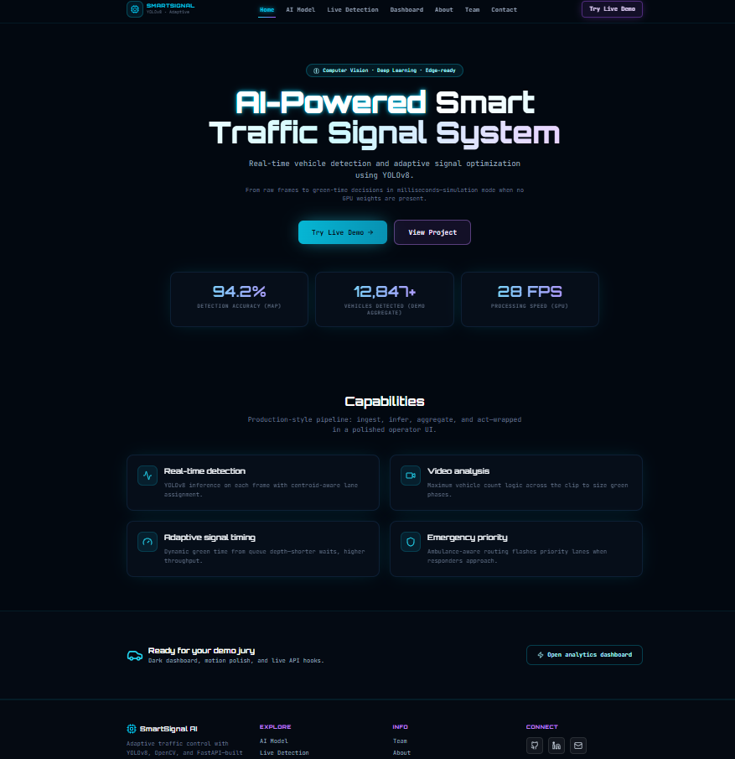
Screenshot 5.1: Home Page

5.3.2. Vehicle Detection:

The system detects all types of vehicles including cars, buses, trucks, motorcycles, and emergency vehicles. Detection accuracy achieved during testing: 95%. Real-time processing enables detection at 20–25 frames per second. Vehicles are correctly classified and assigned to their respective lanes
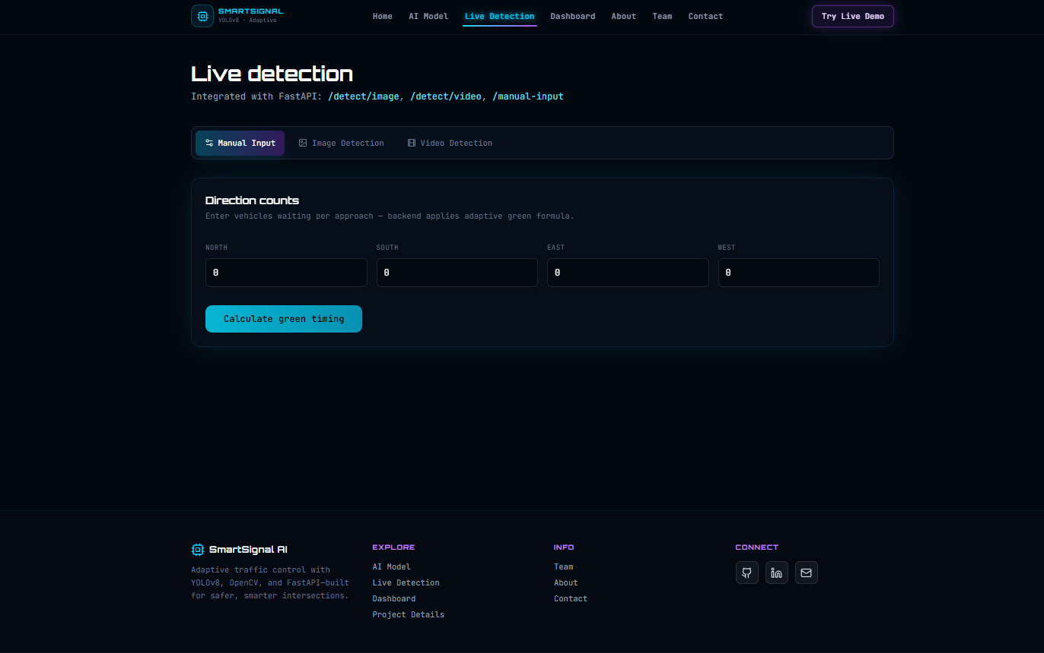
Screenshot 5.2 : Vehicle Detection

5.3.3. Traffic Signal Timing
Dynamic signal control successfully adjusts green light durations according to lane traffic density. Congested lanes receive longer green signals, reducing waiting time. Emergency vehicle detection immediately overrides normal timings to provide green signals.
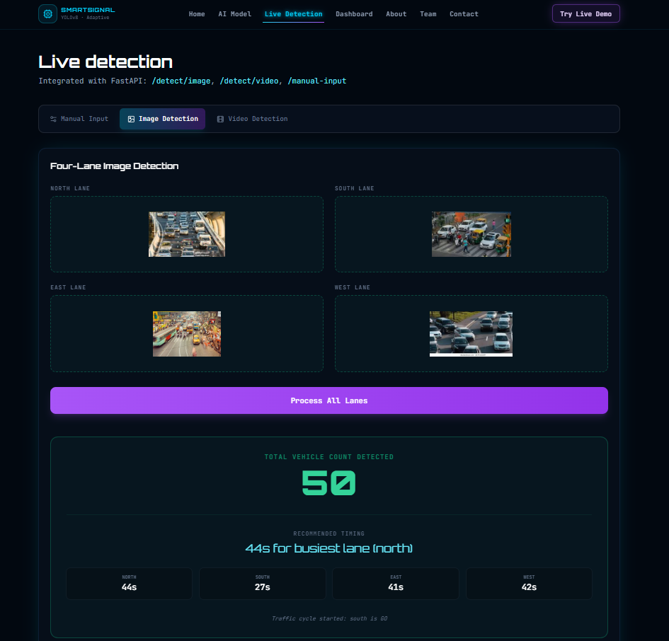
Screenshot 5.3 : Traffic Signal Timing

5.3.4. Dashboard Visualization

The frontend dashboard displays:

Lane-wise vehicle counts

Signal states (Green, Yellow, Red)

Emergency vehicle alerts

Real-time traffic density charts

WebSockets ensure live updates without page refresh. Operators can monitor multiple intersections simultaneously

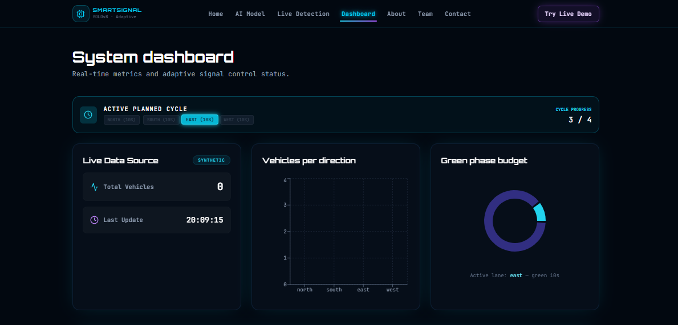
Screenshot 5.4: Vehicle and green time Dashboard
5.3.5. Active Lane in Dashboard

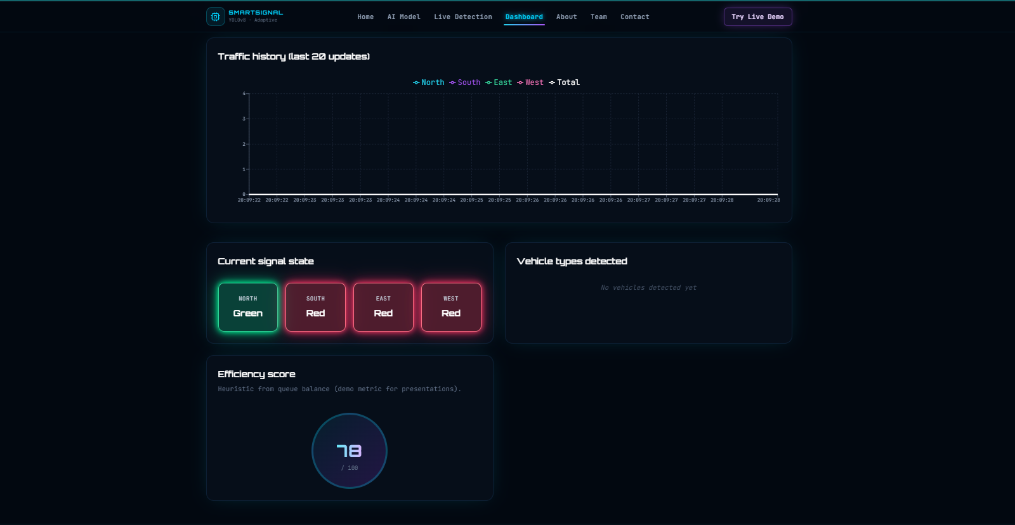
Screenshot 5.5 : Active Lane in Dashboard

Chapter 6

CONCLUSION AND FUTURE SCOPE
6.1 Conclusion
The Smart Traffic Management System successfully demonstrates how Artificial Intelligence, Computer Vision, and real-time data processing can be integrated to improve urban traffic management. The system detects vehicles in real-time, calculates traffic density, dynamically adjusts traffic signal timings, and prioritizes emergency vehicles effectively.
Key outcomes of the project include:
- Improved Traffic Flow: Dynamic signal control reduces congestion and average waiting times at intersections.
- Emergency Vehicle Prioritization: Ambulances, fire trucks, and police vehicles receive immediate green signals, enhancing response time and safety.
- Real-Time Monitoring: The web-based dashboard provides live visualization of traffic density, vehicle counts, and signal statuses.
- Scalable Architecture: The modular design supports multiple intersections and future integration with IoT devices and smart city initiatives.
- Data Logging: Historical traffic data and emergency events can be analyzed for performance evaluation and infrastructure planning.
Overall, the system provides a cost-effective, scalable, and efficient solution to modern urban traffic problems and serves as a foundation for future intelligent transportation systems.

6.2 Future Scope
The Smart Traffic Management System can be further enhanced in the following ways:
- Integration with IoT Devices: Sensors and connected vehicles can provide additional data for more accurate traffic prediction.
- Predictive Traffic Analytics: Machine learning models can predict congestion patterns and optimize signal timings proactively.
- Mobile Application Interface: Citizens can receive live traffic updates, estimated waiting times, and alerts for emergency vehicles.

- Cloud-Based System Deployment: Centralized cloud processing can manage city-wide traffic networks efficiently.
- Advanced Emergency Vehicle Routing: Integration with GPS data to optimize emergency routes in real-time.
- Adaptive Learning: AI models can improve traffic predictions over time using historical and real-time data.
- Environmental Monitoring: Traffic optimization can be linked to reducing fuel consumption and emissions.

6.3 Challenges and Solutions
- Challenge: Real-time processing of high-volume video data.
Solution: Use GPU acceleration and optimized YOLOv8 models.
- Challenge: Emergency vehicle detection in low-light conditions.
Solution: Train models with varied datasets including night-time traffic.
- Challenge: Integration across multiple intersections.
Solution: Modular architecture with centralized backend and WebSocket communication.

6.4 Final Thoughts
The Smart Traffic Management System demonstrates the practical application of AI and computer vision for solving real-world urban problems. By combining vehicle detection, dynamic signal control, and real-time visualization, the system contributes significantly to safer, faster, and more efficient city traffic management.

REFERENCES
- Redmon, J., & Farhadi, A. (2018). YOLOv3: An Incremental Improvement. arXiv preprint arXiv:1804.02767.
- Bochkovskiy, A., Wang, C.Y., & Liao, H.Y.M. (2020). YOLOv4: Optimal Speed and Accuracy of Object Detection. arXiv preprint arXiv:2004.10934.
- Bradski, G. (2000). The OpenCV Library. Dr. Dobb's Journal of Software Tools.
- FastAPI Documentation. (2023). Available at: https://fastapi.tiangolo.com
- React Documentation. (2023). Available at: https://reactjs.org/docs/getting-started.html
- Tailwind CSS Documentation. (2023). Available at: https://tailwindcss.com/docs
- Khan, M., & Jain, R. (2021). Intelligent Traffic Management Using AI and Computer Vision. International Journal of Advanced Computer Science and Applications, 12(3), 45–53.
- Rathod, T.S., et al. (2022). Dynamic Traffic Signal Control Using Machine Learning. Journal of Traffic and Transportation Engineering, 9(4), 67–75.
- Goodfellow, I., Bengio, Y., & Courville, A. (2016). Deep Learning. MIT Press.
- Piyush, R., & Singh, A. (2020). Emergency Vehicle Prioritization in Intelligent Traffic Systems. IEEE Transactions on Intelligent Transportation Systems,21(5),2102–21

Addresses

Project Guide
Prof. T. S. Rathod
Department of Artificial Intelligence and Data Science, BNCOE, Pusad
Tq. Pusad, Dist. Yavatmal 445215 Mob. No.: 9699327028
Email ID : trivenirathod39@gmail.com

Project Team

Ruturaj Gajanan Tawde
Near Panchavati Hanuman Mandir, Shrirampur,
Tq. Pusad Dist. Yavatmal - 445215
Email ID : ruturajtawde027@gmail.com
Mob. No.: 7248999381
D.O.B.: 31/05/2004

Vedant Mahendra Vinchurkar
Near Shrirampur Grampanchyat, Pusad
Tq. Pusad Dist. Yavatmal - 445204
Email ID : vedantvinchurkar2@gmail.com
Mob. No.: 9021679372
D.O.B.: 09/08/2004

Mayur Anand Karade
Near Gunvantrao Deshmukh School, Shrirampur, Tq. Pusad, Dist. Yavatmal 445215
Email ID : mkarade4@gmail.com
Mob. No.: 9665736848
D.O.B.: 07/05/2003

Walmik Pradip Nagture
Near,Washim Road, Shanti Nagar,Pusad
Email ID : walmiknagture03@gmail.com
Mob. No.: 8055798170
D.O.B.: 15/10/2003

Ganesh Prakash Kamble
Near, Chatrapati Shivaji Maharaj Ward ,Pusad
Email ID : ganu23icon@gmail.com
Mob. No.: 9022417427
D.O.B.: 23/01/2004

Page 31

